1. Setup

Prior to running the installation there are a few things that need to be done.

1. Make sure that the project team has filled out the onboarding document. Shortcuts can be found at I:\INF\DataArch\Projects\DBAMSSQL\Installations
   * Either the Database On-boarding Assessment Questionnaire_V1_1.doc OR
   * Application Package Hosting Considerations – Version 1_3.doc
2. Make sure that the media is on the E:\SQL Server Installation. If it isn’t there, then create the directory and copy it over
3. Make sure that the appropriate drives have been created. The sizes of these drives will vary based on the application.

| **Drive** | **Type** | **Raid** | **Usage** |
| --- | --- | --- | --- |
| C:\ | Local Disk |  |  |
| E:\ | Local Disk |  | Dumps / INSTALL Directories |
| K:\ | SAN | Raid 5 | Backups |
| L:\ | SAN | Raid 1 | Transaction Logs |
| M:\ | SAN | Raid 10 | SQL Database |
| T:\ | SAN | Raid 10 | Temp DB |
| Q:\ * | SAN |  | Quorum Drive |

*This drive is for clusters only.

1. Create the following directories:

E:\SQL Server Installation

E:\MSSQLBin

E:\MSSQLBin\Shared

E:\MSSQLBin\Sharedx86

K:\ MSSQLDATA\10.5\Backup

L:\ MSSQLDATA\10.5\Database

M:\ MSSQLDATA\10.5\Database

M:\ MSSQLDATA\10.5\System

T:\ MSSQLDATA\10.5\System

1. Make sure that the WALGREENS\MSSQLDBA group has been added to the Windows Administrator group.
2. Make sure that the WALGREENS\sqlsrvcadm1 (which is the service id) has been added to the Windows Administrator group.
3. Make sure you know the IP address of:
   * The SQL Cluster
   * The primary node
   * The secondary node
4. Request that the following ports be open on the server:

Walnet -> IT Resources -> IT Security Forms -> Firewall Request Form

When doing this you need to request it for the server as well as the dba’s workstations. So include subnets 10.239.16.*; 10.239.17.*; 10.239.18.*; 10.239.19.* , 10.248.88.0/22 (ESST_Standard VDI - off-shore server – only 1433 and 3389)

* + 1433 – SQL Server
  + 1434 – SQL DAC
  + 445 – fileshares
  + 135 – 139 – Remote startup and shutdown
  + 3389 – remote desktop
  + 80 – Reporting Services (when necessary)
  + 35, 661, 433 – Performance Analysis (from IT-S8MP-FOGAPP1 to new server)
  + 3566 – Performance Analysis (from new server to IT-S8MP-FOGAPP1)
  + 1433 ,3566, 49152-65535, 135-139 – Foglight (from IT-S8MP-FOGHB1 to new server)
  + 3356, 49152-65535, 135-139 – Foglight (from new server to IT-S8MP-FOGHB1)
  + From the server open port 25 to CORPSMTP.walgreens.com (this is for email notifications)
  + From the server to NSRV101 (172.29.6.214) for port 445 (this is for our I: drives to be available)

1. Prepare the nodes

Log onto the what will be the primary node of the cluster. Start the installation by going to the E:\SQL Server Installation and double click on the setup.ext. It might take a few minutes to get it started. Click on the word ADVANCED along the left side of the screen.

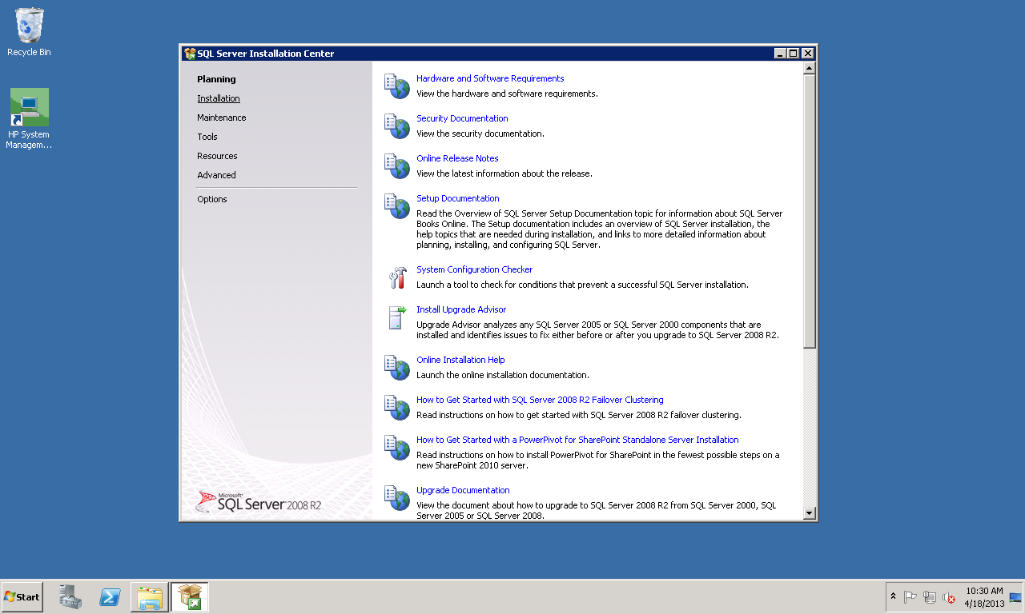

Click on Advanced Cluster Preparation

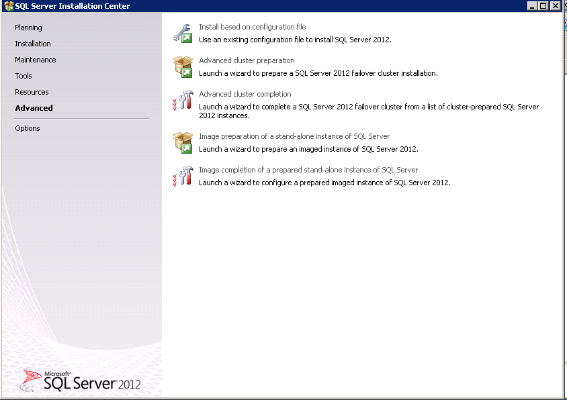

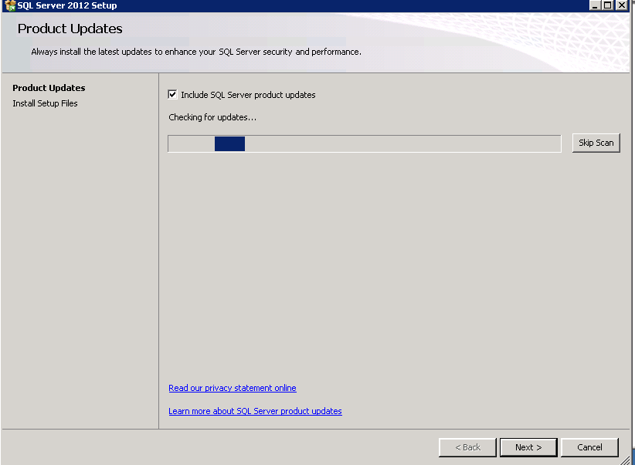You cancel the Scan for Updates and click on Next >

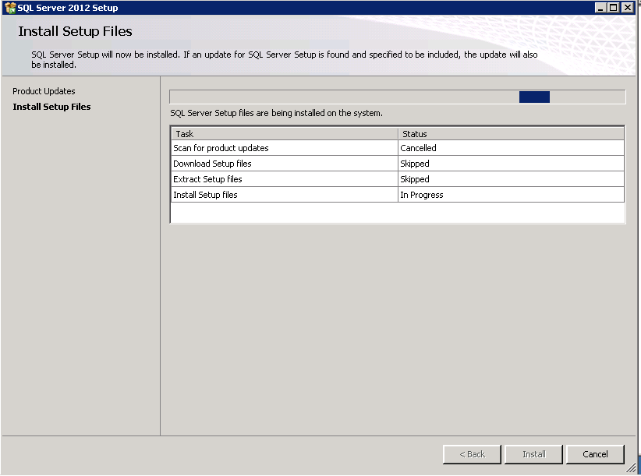

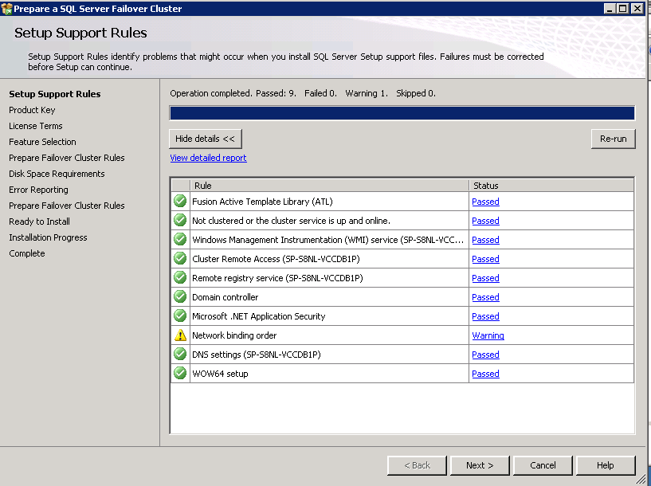

Click on Next >

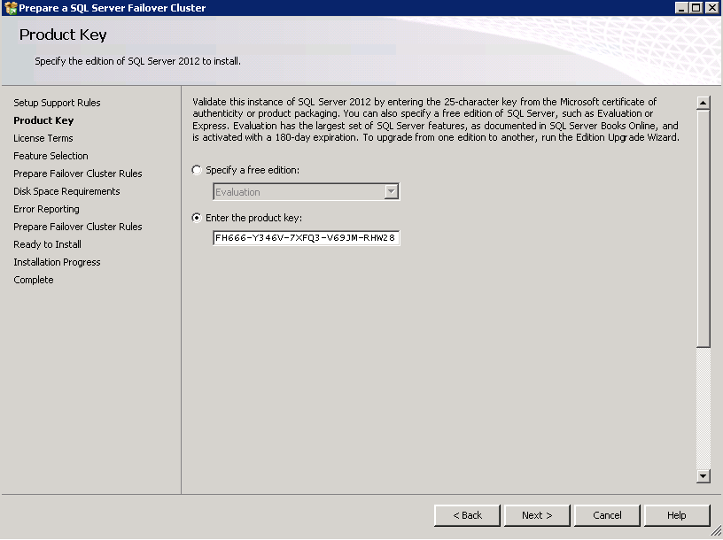

The product keys are already filled in. If they are not, you can find them in the glass file. Click on Next >.

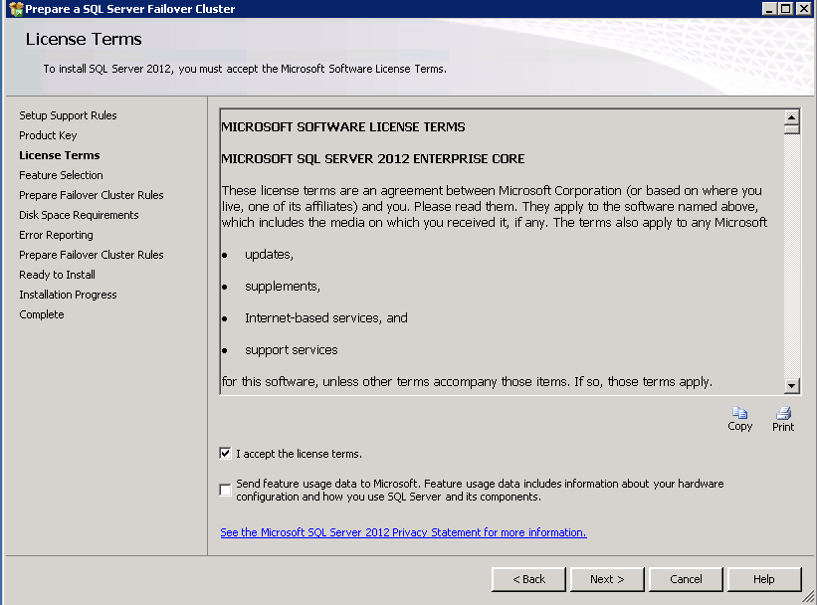

Click on the “I accept the license terms.” And then click Next >.

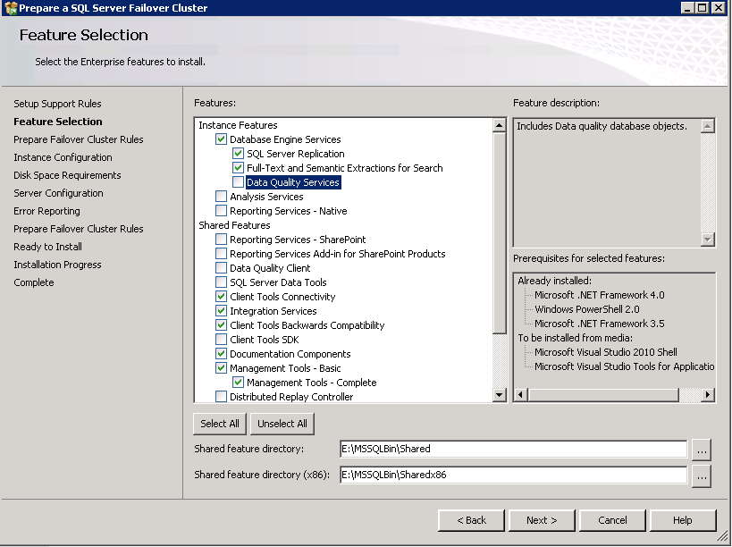

Fill in the screen as indicated. Then click Next >.

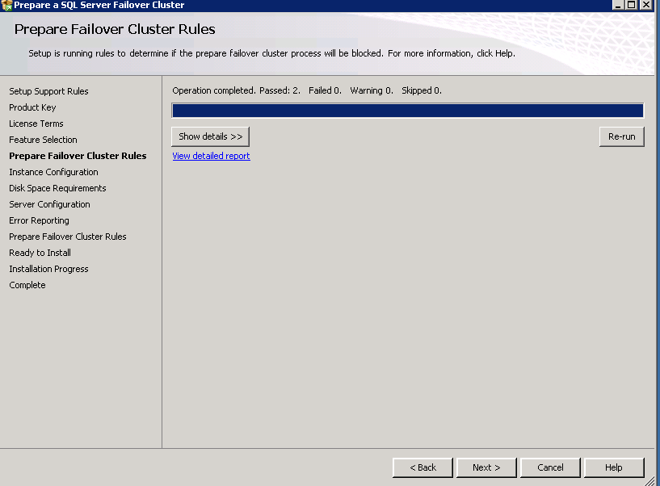

Click Next >

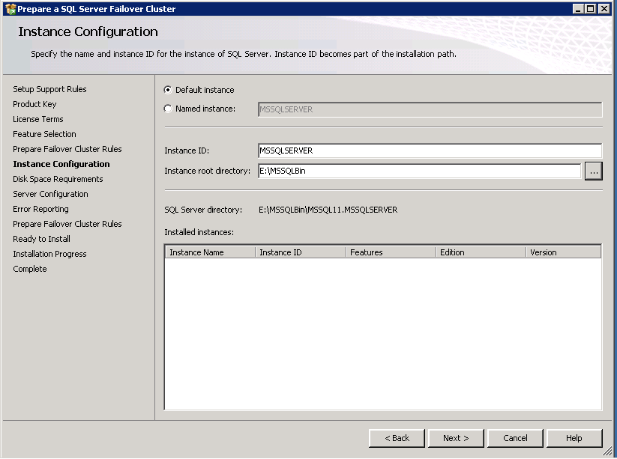

Change the Instance Root Directory and then click Next >

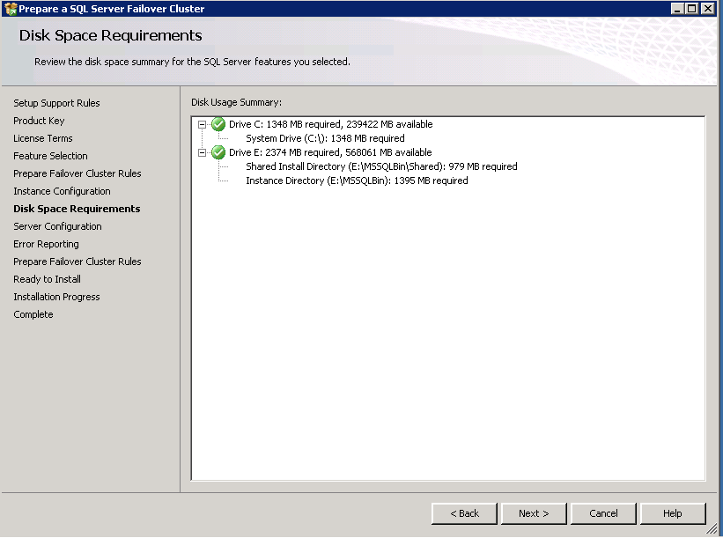

Click Next >

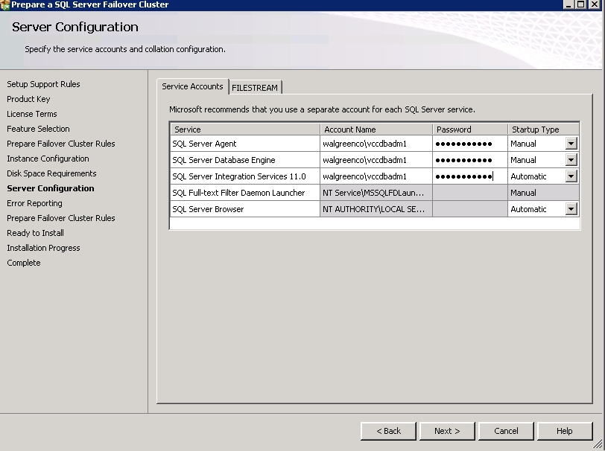

Fill in the Account Names that will be used to run SQL with. Leave the Startup Type to the default at this time.

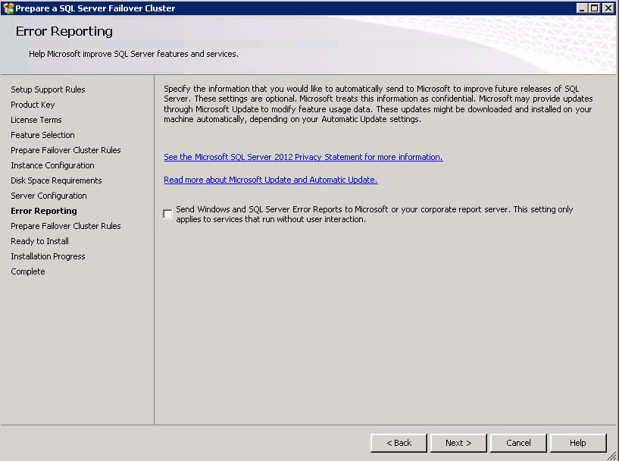

Click on NEXT

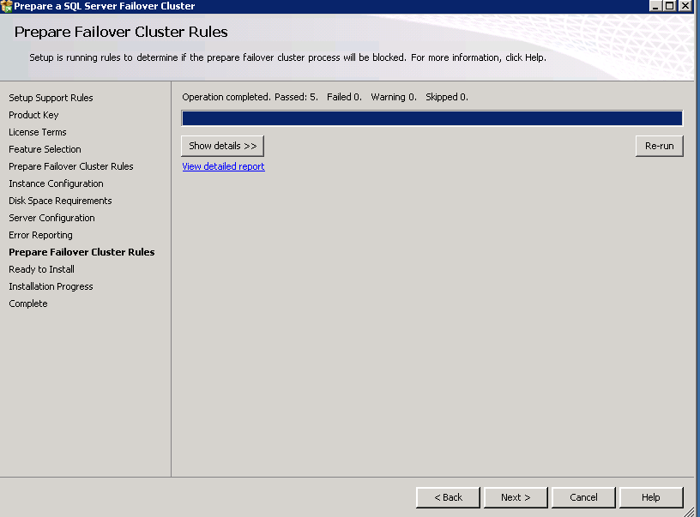

Click on NEXT

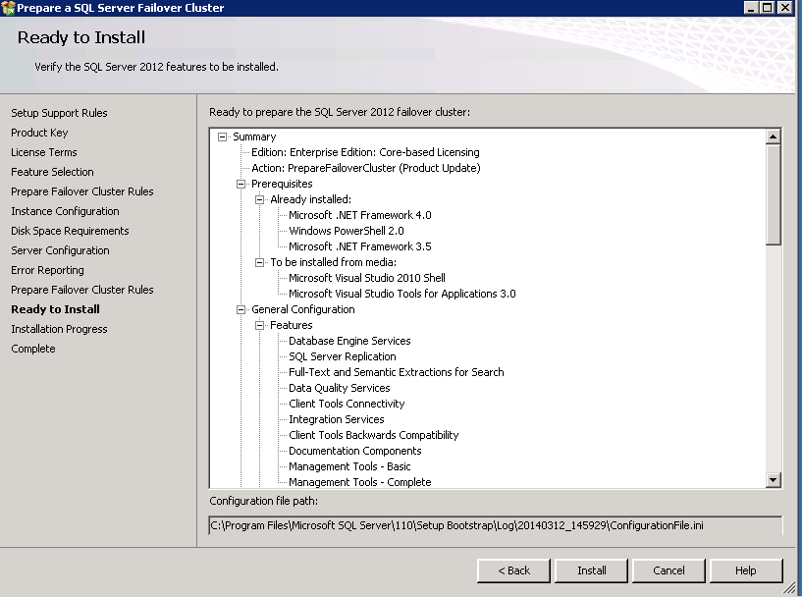

Click on INSTALL

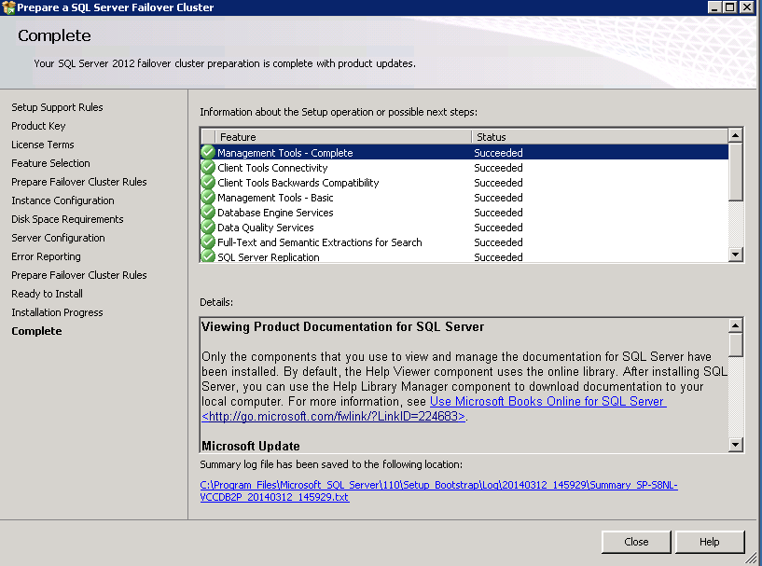

Then log onto the other node of the cluster and do all of the steps above. Don’t forget to make sure the E: drive has the proper folder structure.

Once the second node is complete, then log onto the node that has the shared drives associated with it and click on the setup again. 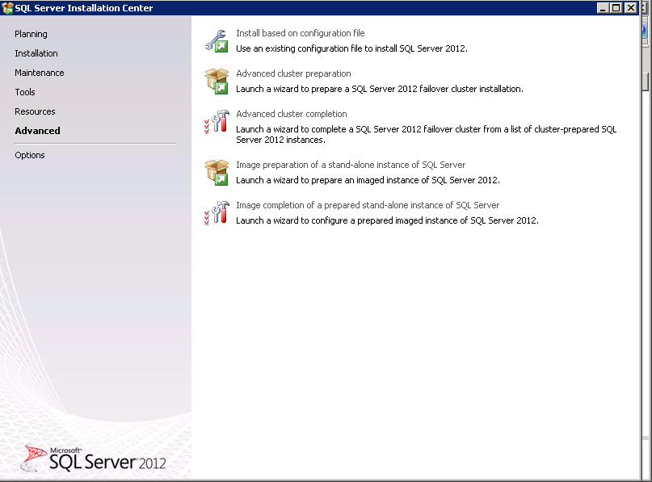

Click on ADVANCED again (on the left side) but this time click on ADVANCED CLUSTER COMPLETION on the right.

Click on OK and Next > until you hit the screen below.

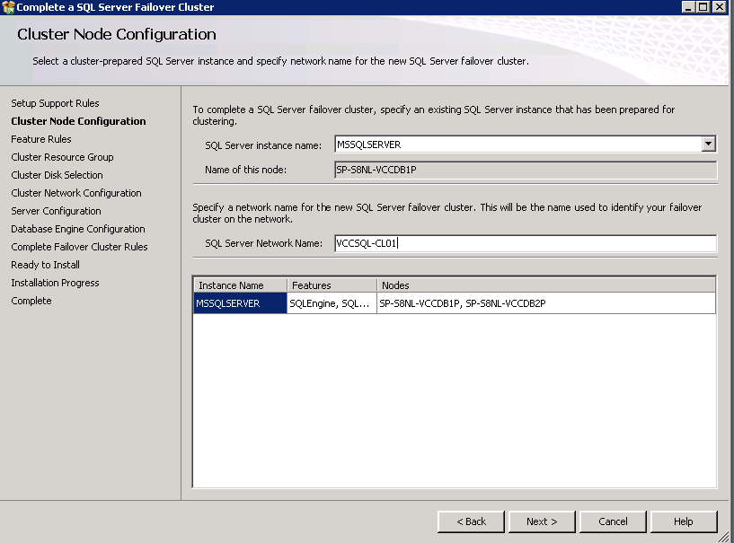

Fill in the SQL cluster’s name.

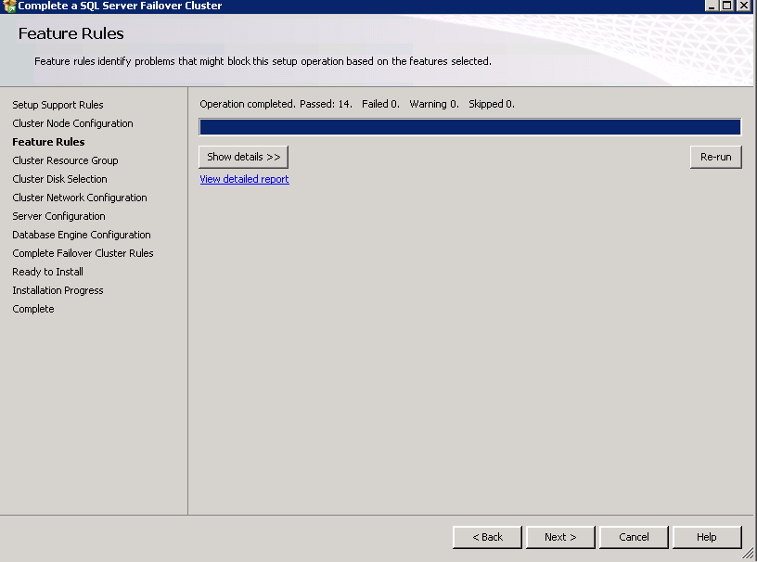

Click Next>

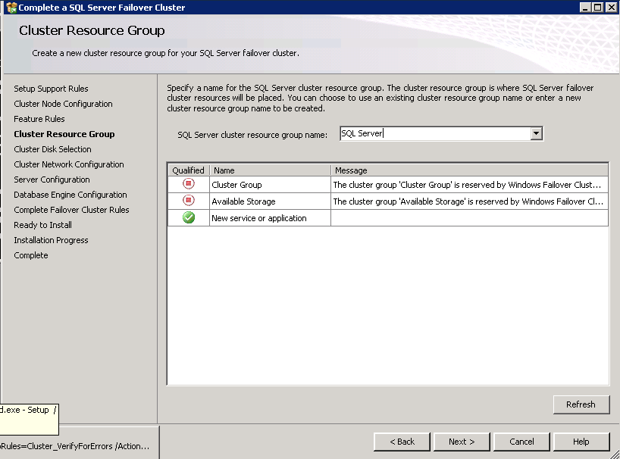

Enter the GROUP that you want SQL to be in.

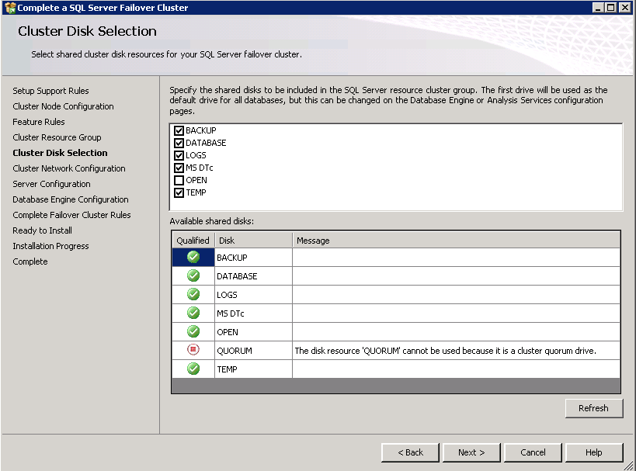

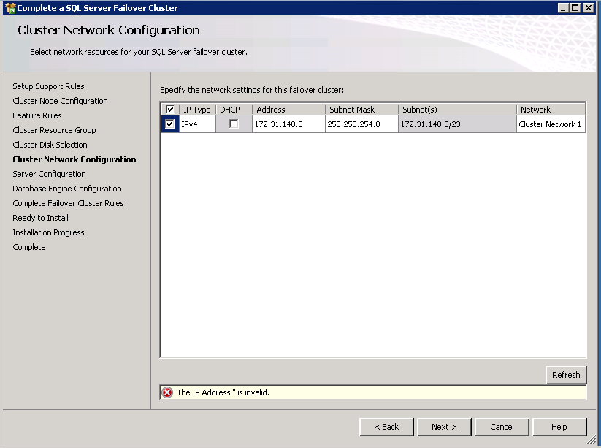

Select IP and then put the IP address of the cluster name.

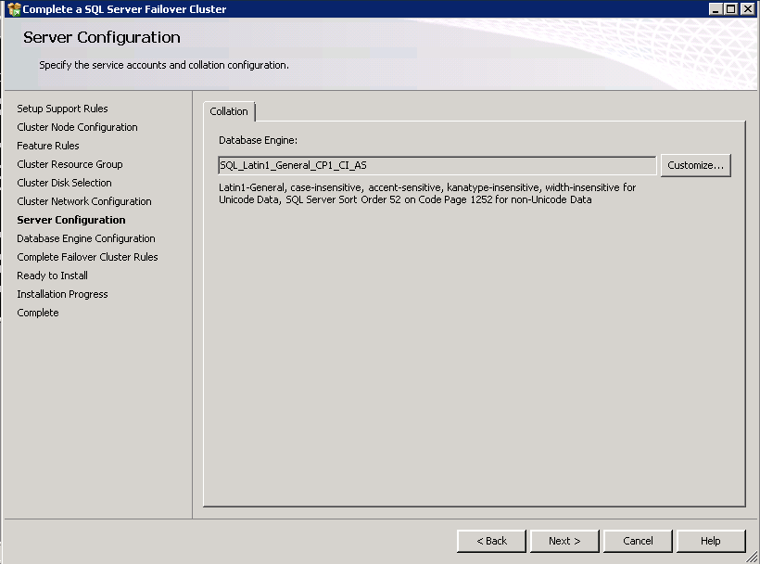

Leave the default (unless you know it must be something else).

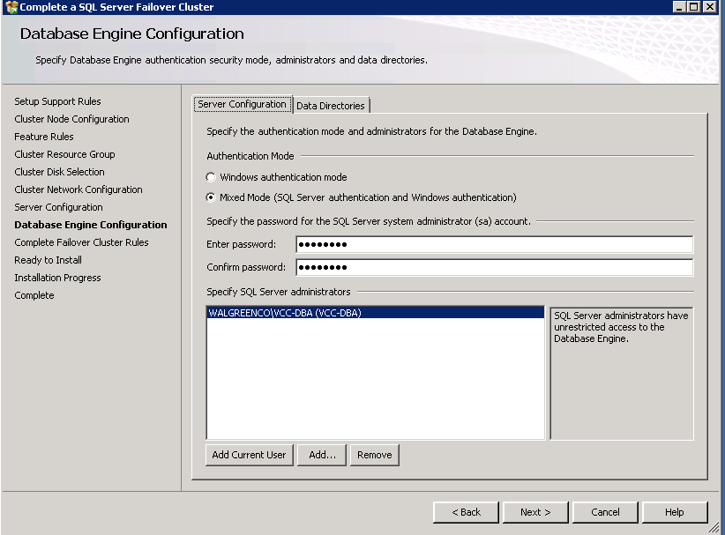

Enter the DBA group for the domain that you are in, and then click on the Data Directories tab.

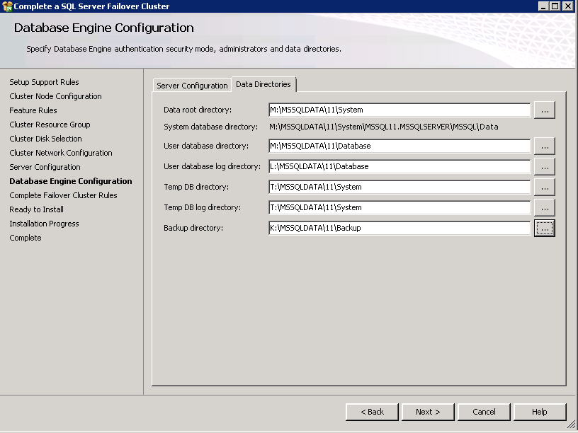

Change the directories to the appropriate drives/folders.

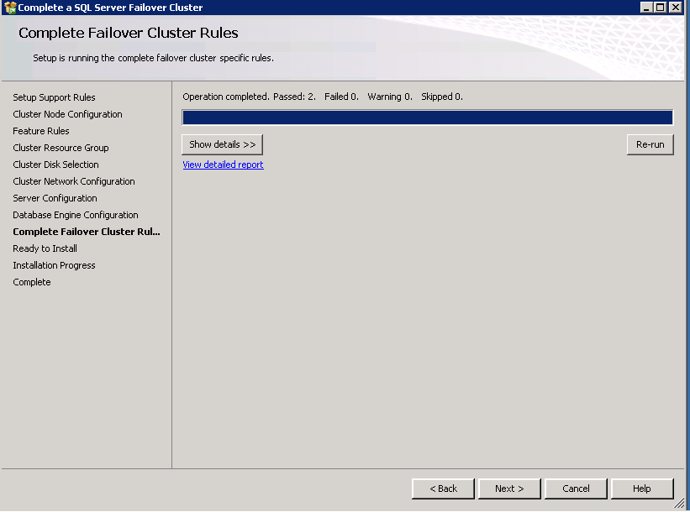

Click Next >

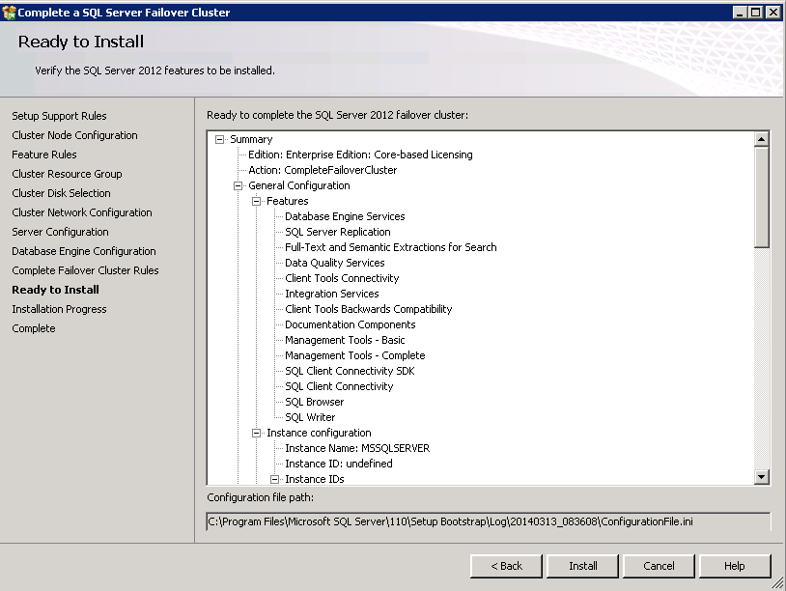

Click Install

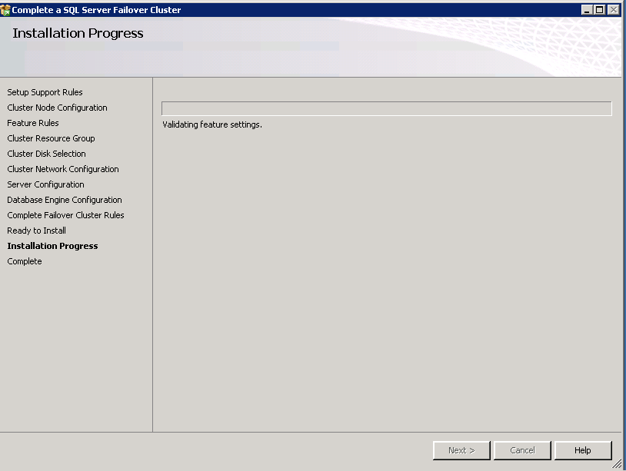

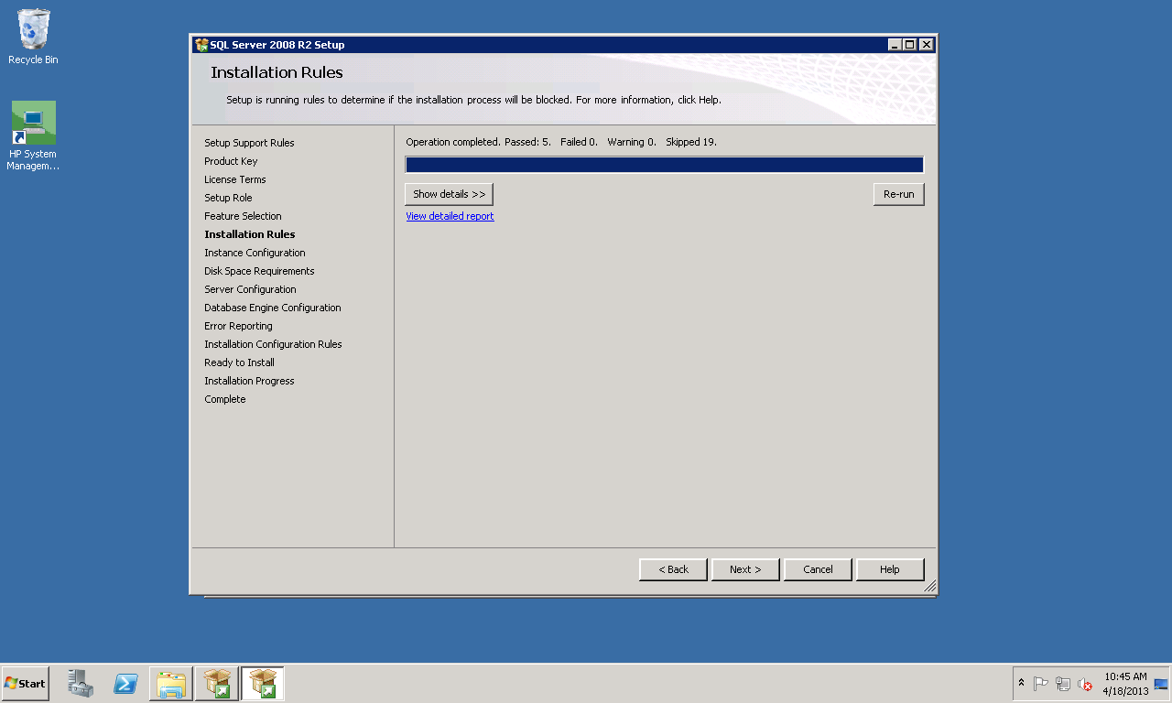

You can click on Show Details to see the actual results. However if you look at the top and see that everything “Passed” then you can just click on Next >

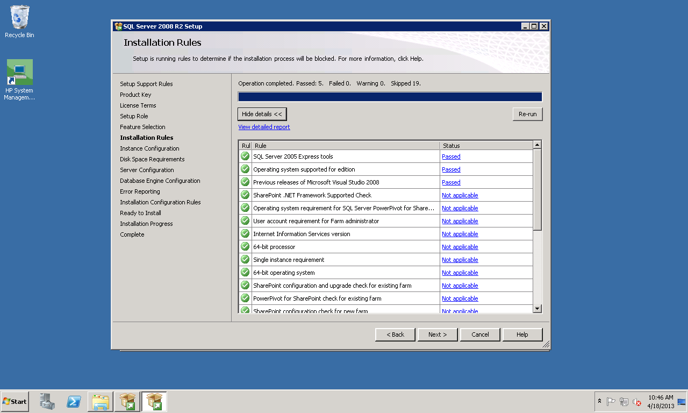

This is an example if you clicked on the “Show Details” from above. Click on Next >

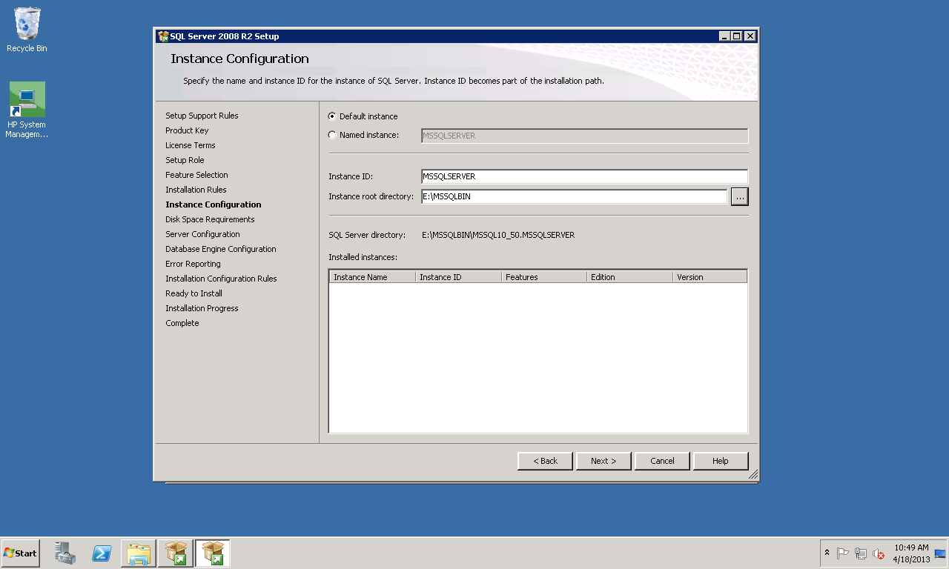

Make sure the “Default instance” radio button is selected. Change the Instance root directory as indicated above and then click on Next >

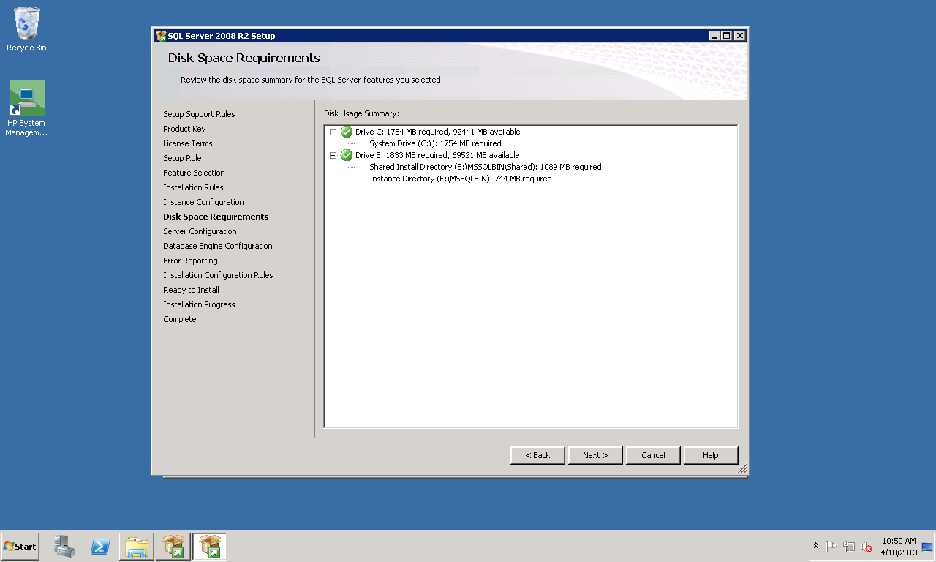

Verify the space availability and click on Next >

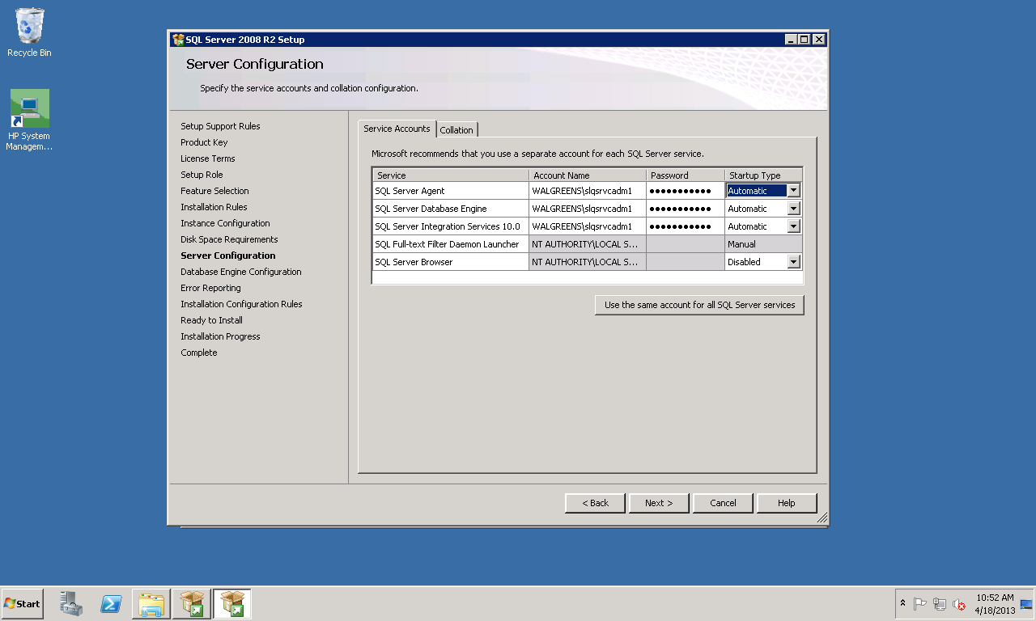

Enter the domain id (WALGREENS\sqlsrvcadm1) and password as indicated on the screen. Change the Startup Type for SQL Server Agent to be “Automatic.” Click on Next >

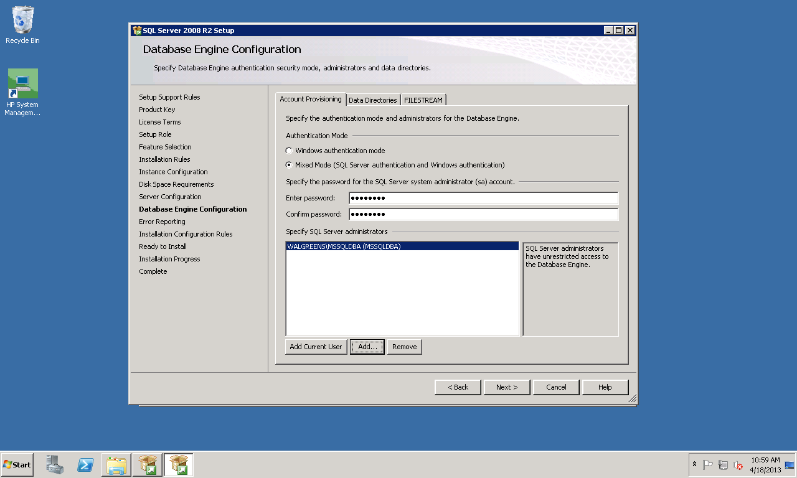

Click on Mixed Mode and enter a password. You will be scrambling this password later. Click on the ADD button to add the MSSQLDBA group to the SQL Server Administrators. Click on the Data Directories tab.

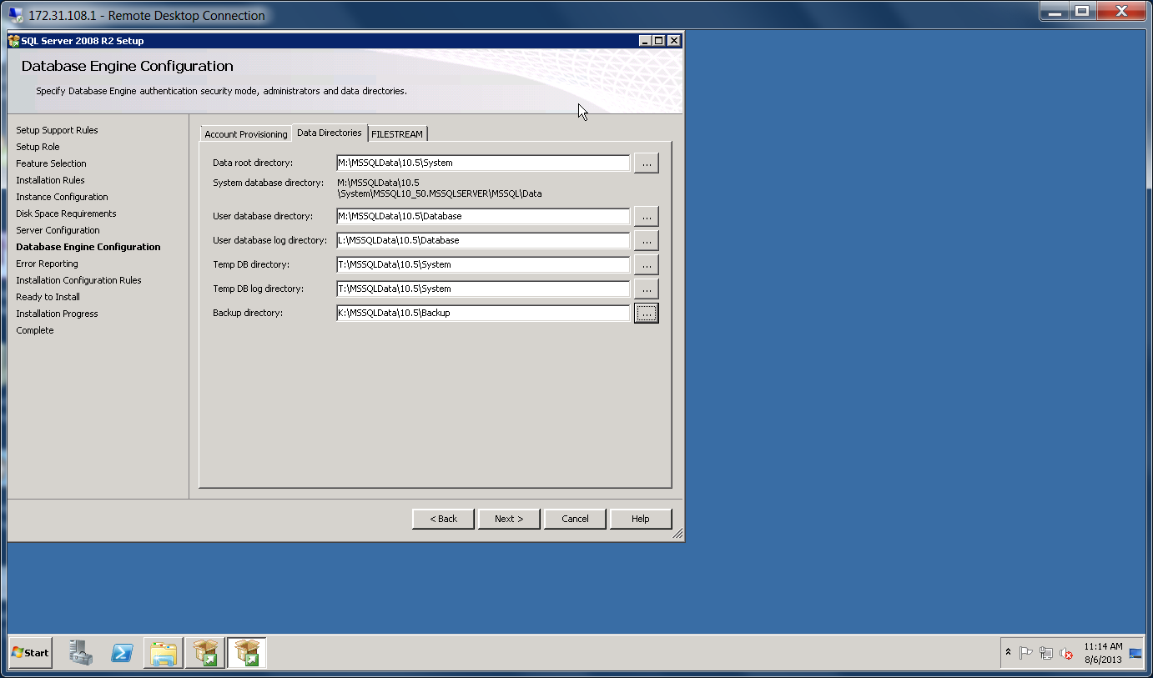

Change the directories as follows on the screen. Then click Next >

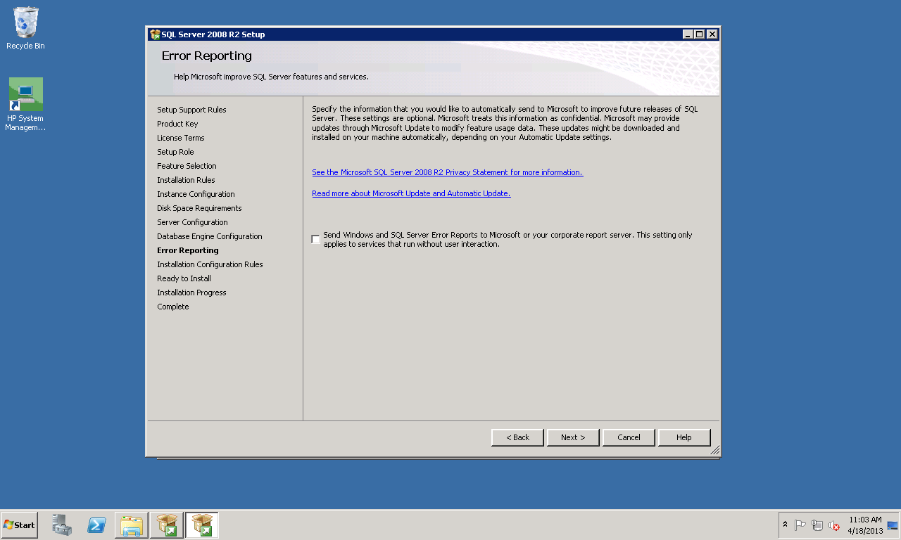

Click on Next >

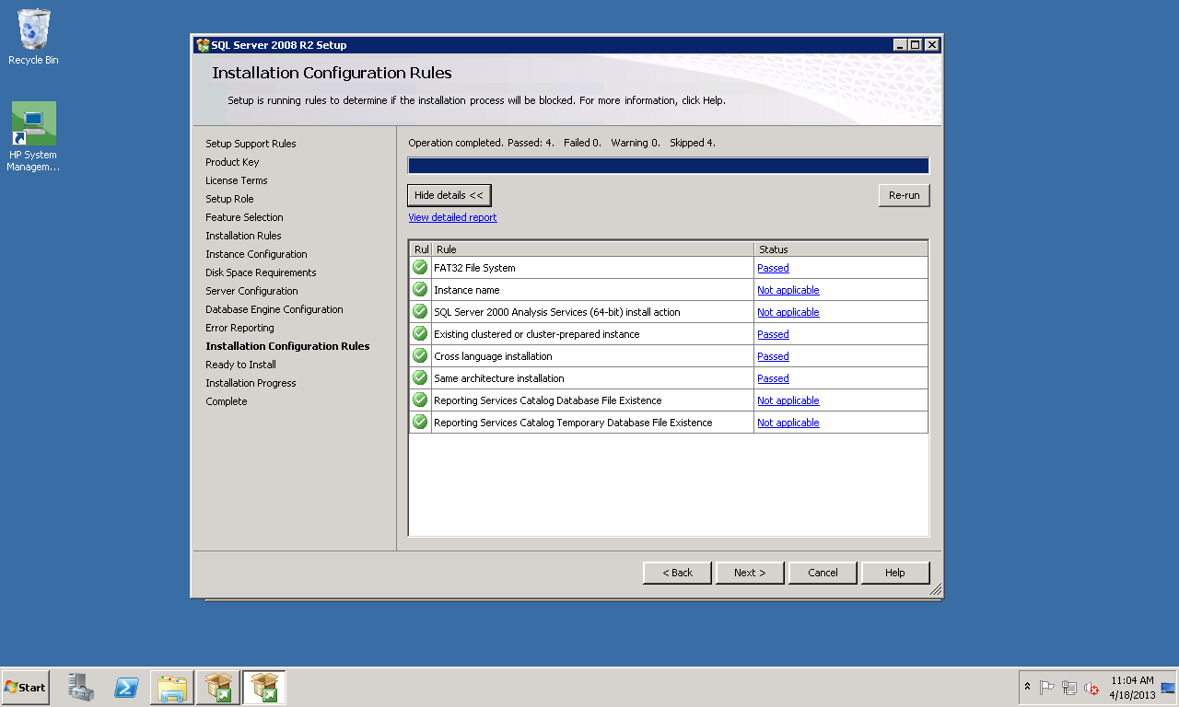

Make sure that everything “PASSED” on the top line. “Show details” has been clicked on to get this screen. You can do that to verify everything. Then click on Next >

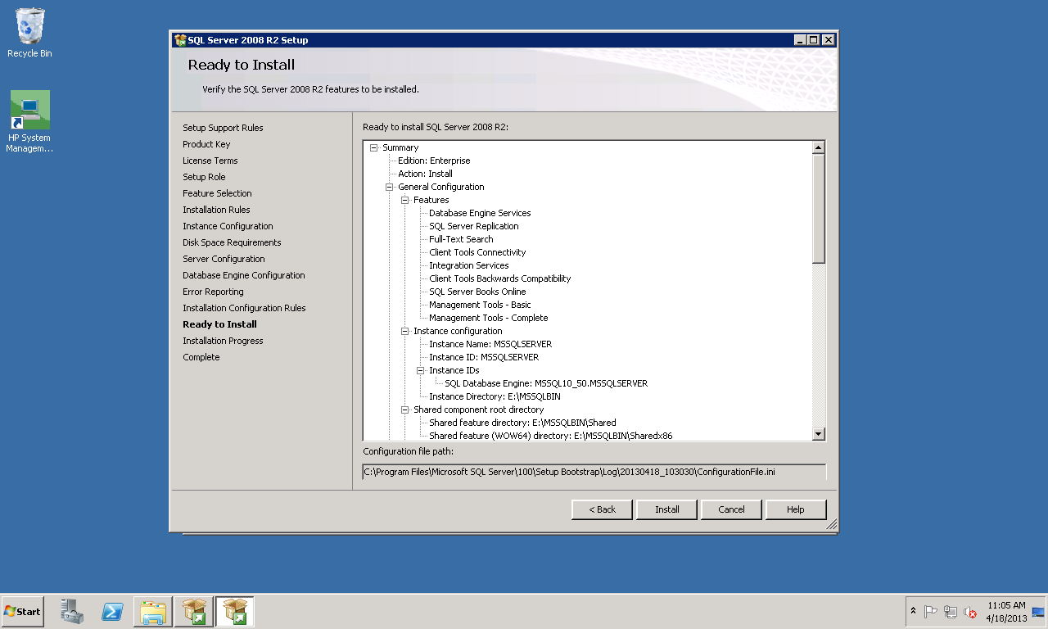

Verify that everything looks good and then click on Install.

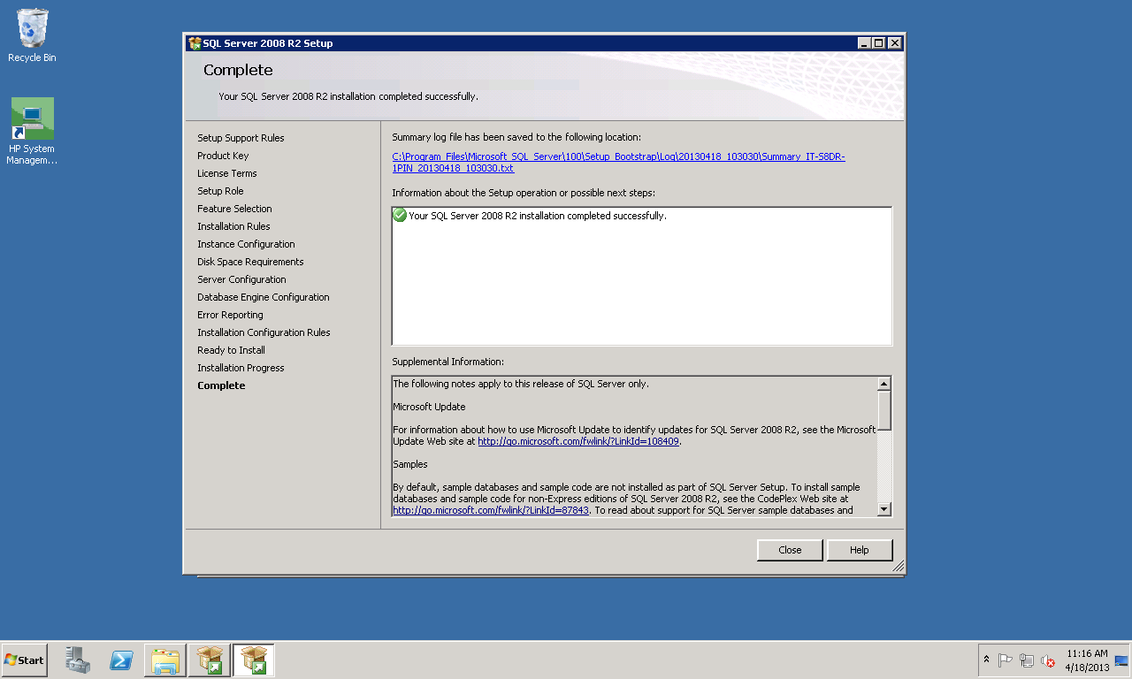

Click on Close

1. Patching / Service Pack

Now you should install the latest service pack. The screen shots below are for SP2.

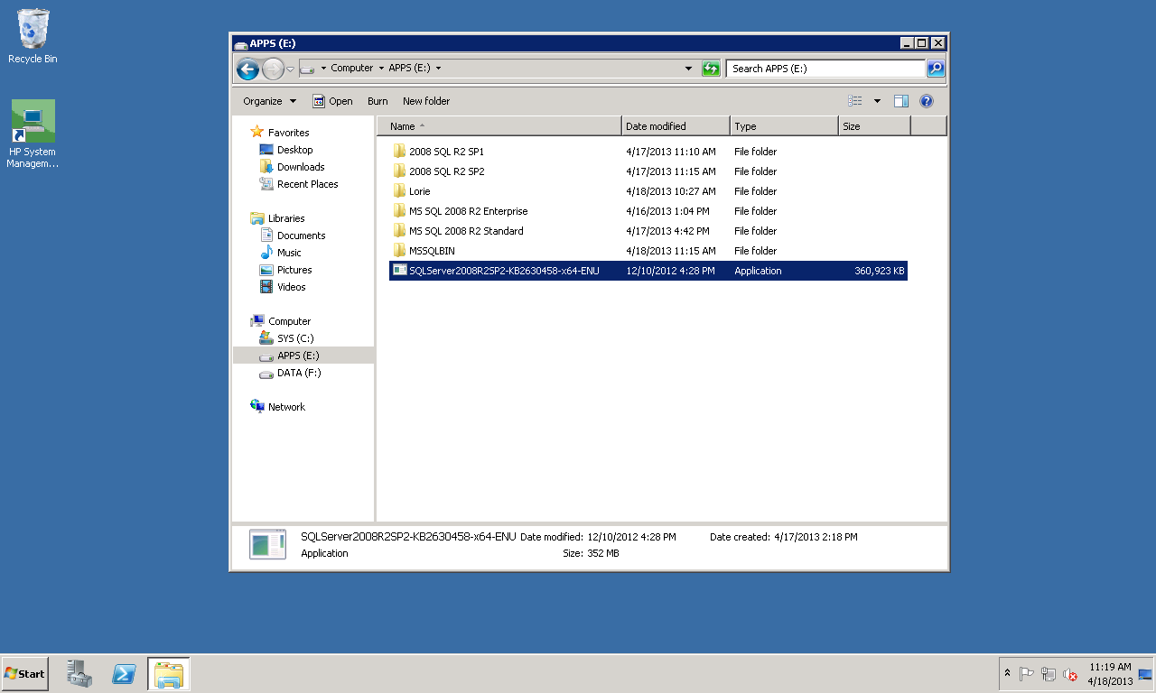

Double click on the link to start the SP2 installation. Sometimes it takes a little bit for the next screen to come up.

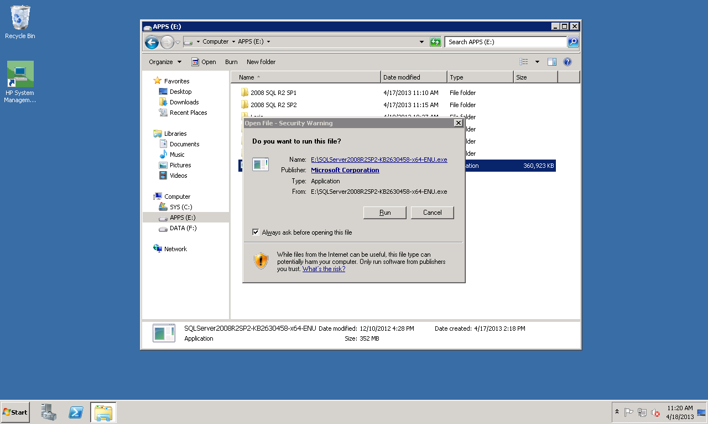

Click on RUN

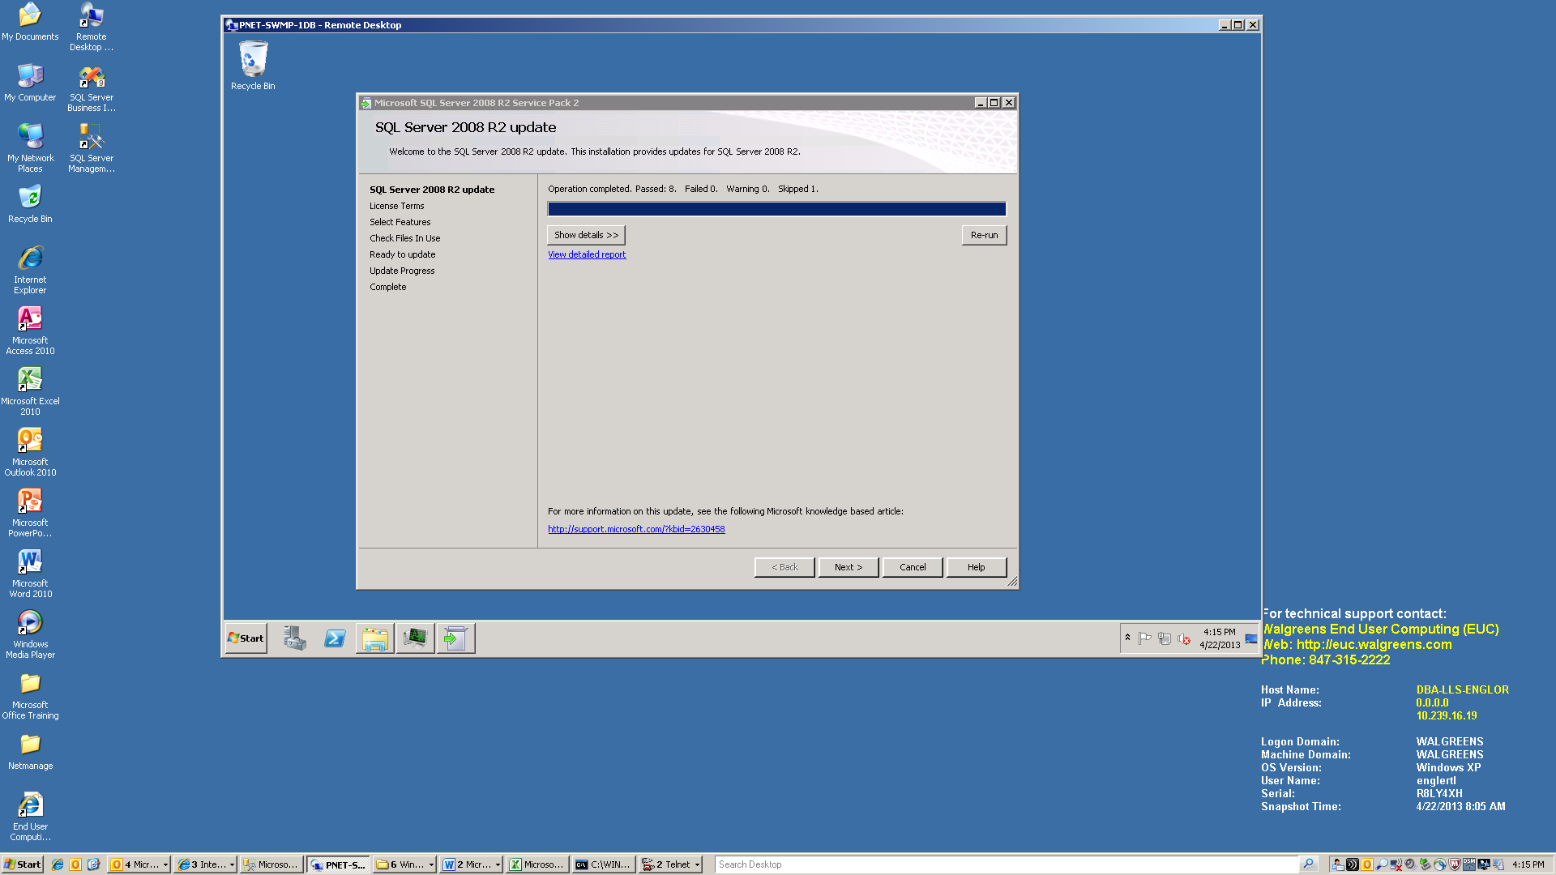

Click on Next >

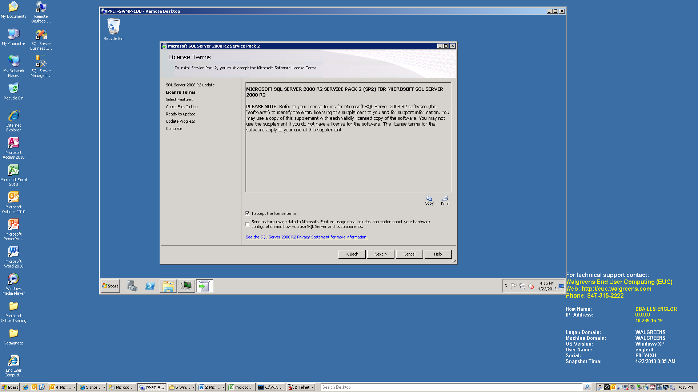

Make sure that “I accept the license terms” is checked and click on Next >

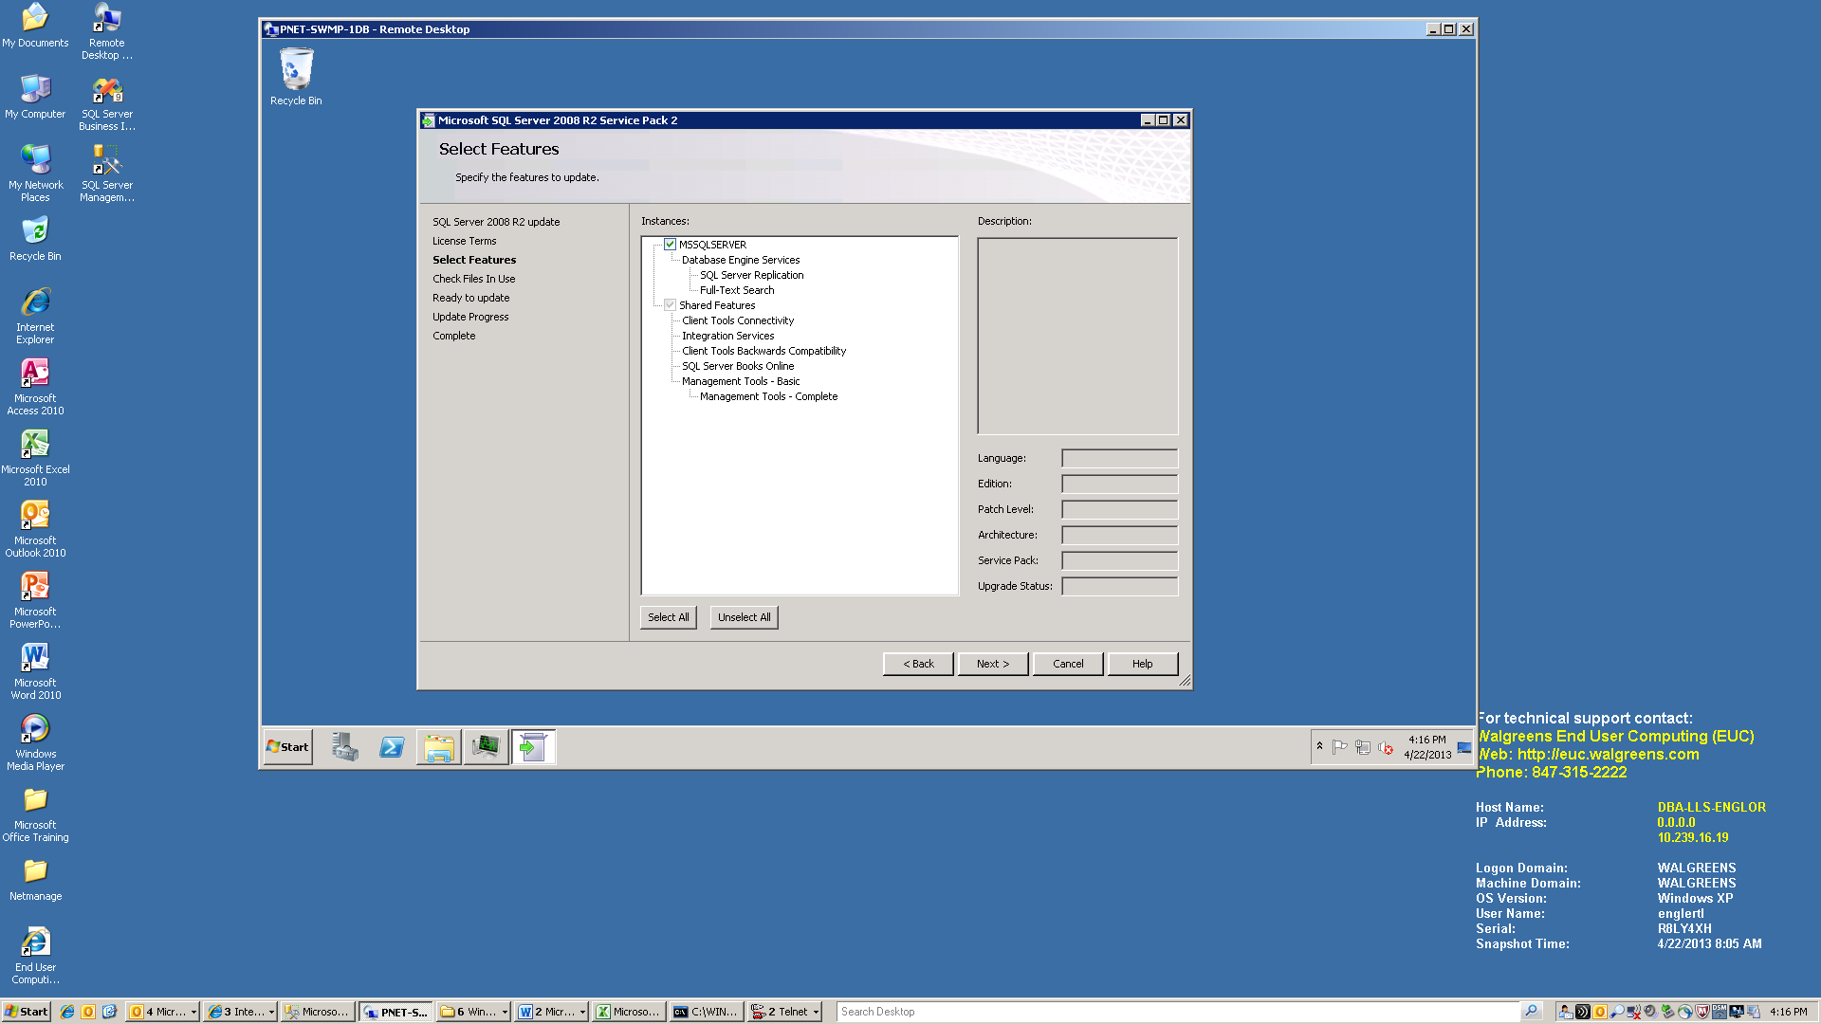

Click on Next >

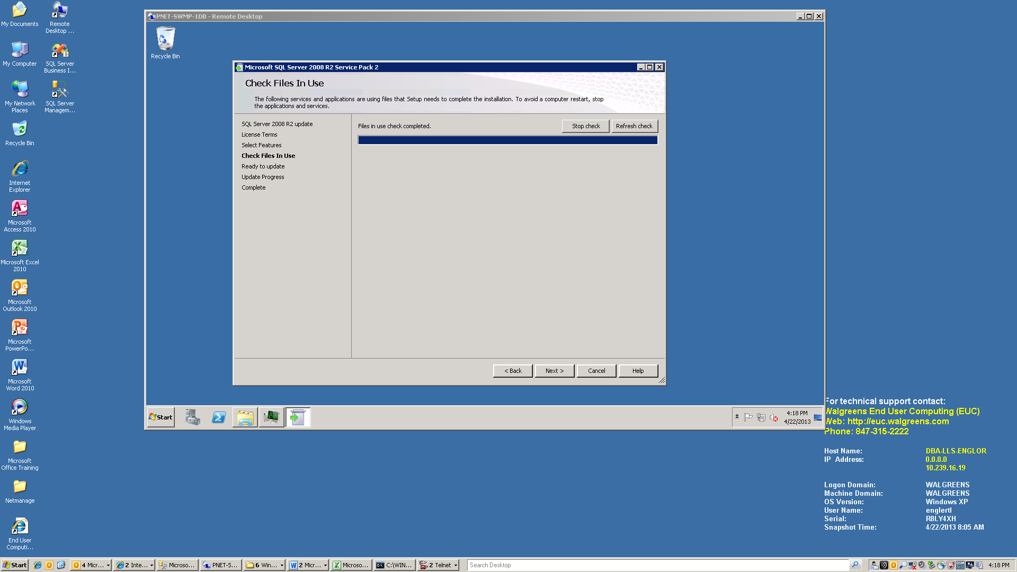

Click on Next >

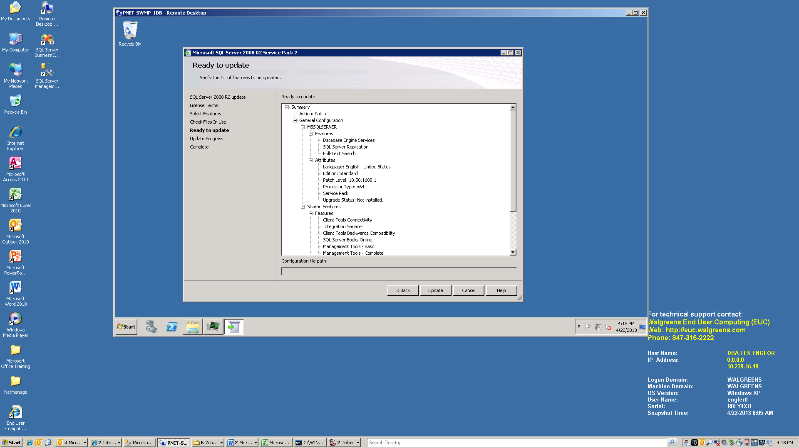

Click on Update

1. Post Installation

There are a few things that need to be done after you have install SQL Server and patched it.

1. Create a new SQL Server id called wagdba and give it sysadmin authority. The password that should be used can be found at I:\INF\DataArch\Admin\glassMSSQL.xlsx. Make sure that you uncheck the “Enforce password policy” box.
2. Reboot the server after installing the service pack.
3. Add more files to the Tempdb (one per core) using the script below.

I:\INF\DataArch\Projects\DBAMSSQL\Installations\Add Tempdb Files

1. Change the Database Defaults on the server
   * Right click on the server/instance and bring up the Properties
   * Click on Database Settings
   * Change the Database default locations (for both the data and log) to be:

M:\MSSQLDATA\10.5\Database (data)

L:\MSSQLDATA\10.5\Database (logs)

1. Create the XAdminDB database
   * DB file size = 512 MB
   * Log file size = 126 MB
   * Owner = SA
   * Change the files to point to
   * Verify that the database is going to the right drives
2. Create the objects in the database

* Run I:\INF\DataArch\Projects\DBAMSSQL\Installations \xadmindbConf.bat <server name>

1. Create the maintenance jobs using the script below. Make sure that you check the script to see that the BackupDirectory path is correct.

I:\INF\DataArch\Projects\DBAMSSQL\Installations \MaintenanceSolution.sql

Then run them to make sure that they work.

1. Schedule the maintenance jobs using:

I:\INF\DataArch\Projects\DBAMSSQL\Installations \Job schedule script.sql

1. Set up OLTP, DB Mail, Operators, Notifications and Initialization

I:\INF\DataArch\Projects\DBAMSSQL\Installations\scr1_OLTP_config.sql

I:\INF\DataArch\Projects\DBAMSSQL\Installations\scr2_Email_setup.sql

I:\INF\DataArch\Projects\DBAMSSQL\Installations\scr3_Add_operators.sql

I:\INF\DataArch\Projects\DBAMSSQL\Installations\scr4_add_notifications.sql

I:\INF\DataArch\Projects\DBAMSSQL\Installations\scr5_perf_initialization.sql

1. Set up other DBA jobs

I:\INF\DataArch\Projects\DBAMSSQL\Installations\Job_Purge_PerformanceData.sql**

I:\INF\DataArch\Projects\DBAMSSQL\Installations\Job_Weekly_Admin_Short.sql

I:\INF\DataArch\Projects\DBAMSSQL\Installations\Job_GetBlockinfo2005.sql

I:\INF\DataArch\Projects\DBAMSSQL\Installations\Job_Monitor_Capacity.sql

I:\INF\DataArch\Projects\DBAMSSQL\Installations\Job_Monitor_Performance.sql

** This is for “normal installations.” In the case of a Tier1 application, run this script instead: I:\INF\DataArch\Projects\DBAMSSQL\Installations\Job_Purge_PerformanceData_HighTier.sql

1. Scramble the SA password

I:\INF\DataArch\Projects\DBAMSSQL\Installations \Scramble SA Password.sql

1. Backup the Service Master Key

The Service Master Key is the root element of all encryption hierarchy in the SQL Server Instance. It will be used on all actions in SQL Server which have a relation to certificates (i.e. Transparent Data Encryption). Backup the key to a file by using the following script

I:\INF\DataArch\Projects\DBAMSSQL\Installations\Backup Service Master Key.sql

and then put a copy it to the I:\INF\DataArch\Projects\DBAMSSQL\Installations\Service Master Key folder. You should also add it to the glassMSSQL.xls spreadsheet.

1. Update the Memory configuration

Use the script below to configure the memory on the server. The MAX SERVER MEMORY parameter may have to be modified based on the following considerations:

* The RAM on the server
* If Tivoli or Foglight is running on the server (reserve 1 GB)

In general, you want to want to reserve 1 GB of RAM for other processing. However if you have Tivoli or Foglight running you should reserve another 1 GB of RAM for it. Therefore if you have a server with 4 GB of RAM and you had Tivoli installed you would make this figure be 2048 (4096 – 1024 for other processing – 1024 for Tivoli).

I:\INF\DataArch\Projects\DBAMSSQL\Installations\Configure Memory.sql

1. Create a Media Management ticket to have the windows backups taken

On IE page EBRS

Forms Tab -> New Backup -> Network/VM (since they don’t have SQL Server listed)

1. Add the server to the inventory spreadsheet.

Testing:

Fail the node over several times

Make sure the dependencies are correct

Make sure that dependencies stop SQL as required (backup drive should not bring the services down)

SQL Agent Depends on SQL Server

SQL Server Depends on M: and T;

L: or K: drives